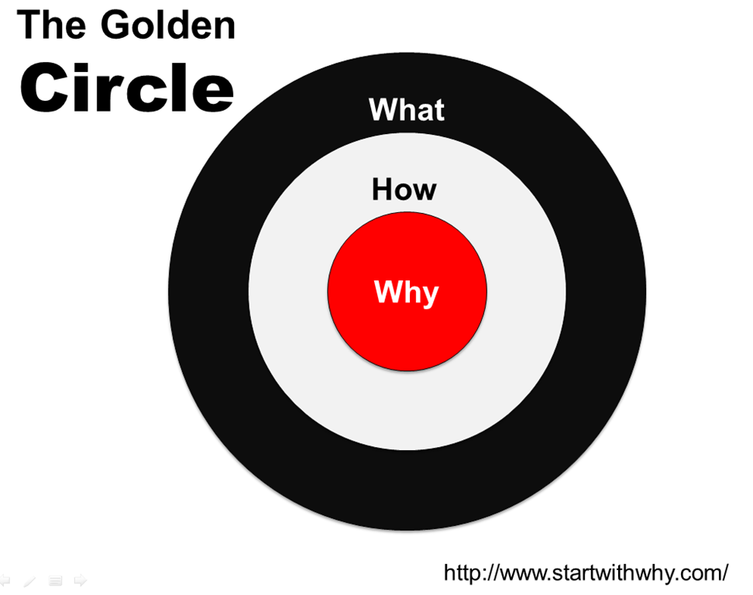
Credit to Simon Sinek: https://www.ted.com/speakers/simon_sinek
http://www.ted.com/talks/simon_sinek_how_great_leaders_inspire_action?language=en
https://www.ted.com/talks/simon_sinek_why_good_leaders_make_you_feel_safe
Martin Luther King, Jr. said, “I have a dream,” not I have a plan.

What happens if I start with something (a program, an initiative, an approach)?
What?
How?
Why?

What happens if I start with the Why? Because we…
Why are you a School Counselor?
People don’t buy what you do, they buy why you do it
People do what they believe.
What you do is simply proof of what you believe.

Everyone knows what they do.
Some know how they do it.
Very few people know why they do what they do? (purpose, call, belief, why does this role, this purpose exist)
We typically communicate from the outside in. Inspirational people act from the inside out.
Why? Everything we do is because we believe children…
How? We invest ourselves in things/approaches/small groups, etc.
What? The particulars

