Today’s Training: http://ncregion2.ncdpi.wikispaces.net/Support+Staff+Standards+for+Administrators
Support Services Wiki: http://ncees.ncdpi.wikispaces.net/Support+Staff
1. Training
2. Orientation-within first two weeks
3. Self-Assessment
4. School Counselors also have the Annual Agreement (https://ncregion2.ncdpi.wikispaces.net%2Ffile%2Fview%2FAnnualAgreement%2520NC%2520version.doc%2F487231712%2FAnnualAgreement%2520NC%2520version.doc)
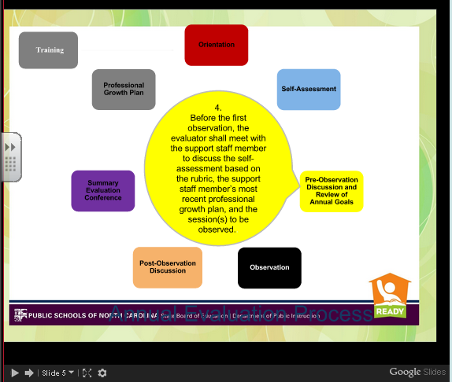
5. Three observations- no short form- must look at all 5 standards each time observed, but you may not see all five in each session. (Career- 1 formal and 2 informal-20 minutes)
6. Post Observation within 10 working days
7. Summary Evaluation
8. Develop PGP based on this year’s information

Standards:
Standard 1: school counselors demonstrate leadership, advocacy, and collaboration. Professional school counselors demonstrate leadership, advocacy, and collaboration by developing a positive place for students and staff members to learn and grow. School counselors manage a comprehensive school counseling program that supports academic, career, and personal/social development for all students. School counselors advocate for equity for all students and staff members regardless of learning style, cultural background, or individual learning needs. School counselors improve the counseling profession by demonstrating high ethical standards and by following the codes of ethics set out for them.

Standard 2: School counselors promote a respectful environment for a diverse population of students. Professional school counselors establish a respectful school environment to ensure that each student is supported by caring staff. School counselors recognize diversity and treat students as individuals, holding high expectations for every student. Knowing that students have many different needs, school counselors work to identify those needs and adapt their services to meet them. School counselors recognize the fact that many adults share responsibility for educating students and collaborate with them to facilitate student academic success.
Standard 3: school counselors understand and facilitate the implementation of a comprehensive school counseling program. Professional school counselors align their programs with state and national best practices to ensure that their role fits into the school program. A comprehensive school counseling program meets the academic, career, and social/emotional developmental needs of students through the implementation of programming including individual counseling, classroom presentation, academic advising, career development services, consultation, parent education and other responsive services. School counselors deliver a comprehensive school counseling program for all students and provide developmentally-appropriate services and activities based on student needs. A school counselor must engage in leadership, advocacy, and collaboration with all school personnel for the successful implementation of a comprehensive school counseling program. School counselors understand how students learn and help all students develop in the areas of academic, career, and personal social success. School counselors align their services with the North Carolina Standard Course of Study to meet the needs of students.
Standard 4: School counselors promote learning for all students. Professional school counselors are knowledgeable of the ways in which learning takes place and understand the significance of academic, career, and personal/social development of all students. School counselors work to eliminate barriers that students may experience. School counselors use data to plan programs that help students develop their academic and career-related skills as well as their abilities to relate cooperatively and effectively with other people. School counselors use a variety of methods to implement programs that will help raise achievement and close gaps. School counselors help students think through their problems and find solutions. School counselors listen and communicate well, and they model those behaviors for others around them.
STANDARD 5: SCHOOL COUNSELORS ACTIVELY REFLECT ON THEIR PRACTICE. Professional school counselors demonstrate accountability for managing and delivering a comprehensive school counseling program. School counselors analyze formal and informal data to evaluate their programs in a deliberate on-going manner. School counselors participate in professional development opportunities that support the school and district’s mission as well as the comprehensive counseling program. School counselors recognize that change is constant and use best practices to continually improve their programs.
Deep Dive Into Standards:
Link on site to evidences on Google Doc
Suggestions:
- Try to observe three very different activities
  - A parent meeting
  - A professional development
  - Student lesson (But you may not see many of these elements in a student lesson)

